1. Every()

function verify_ages(x){

return x >= 18; }

function check_num(x){

return x>=0; }

var ages

ages = [32,33,16,40];

ages.every(verify_ages);

false

ages.every(check_num);

true

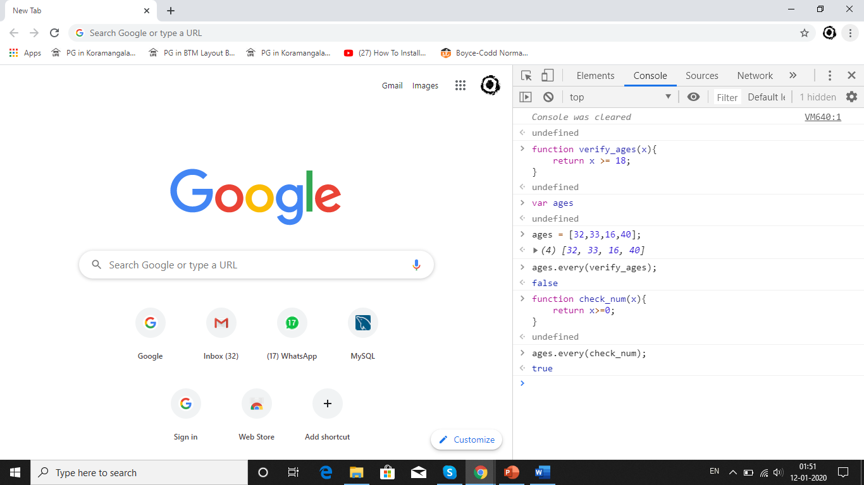

1. Filter()

ages.filter(verify_ages);

*(3) [32, 33, 40]*

ages.filter(check_num);

*(4) [32, 33, 16, 40]*

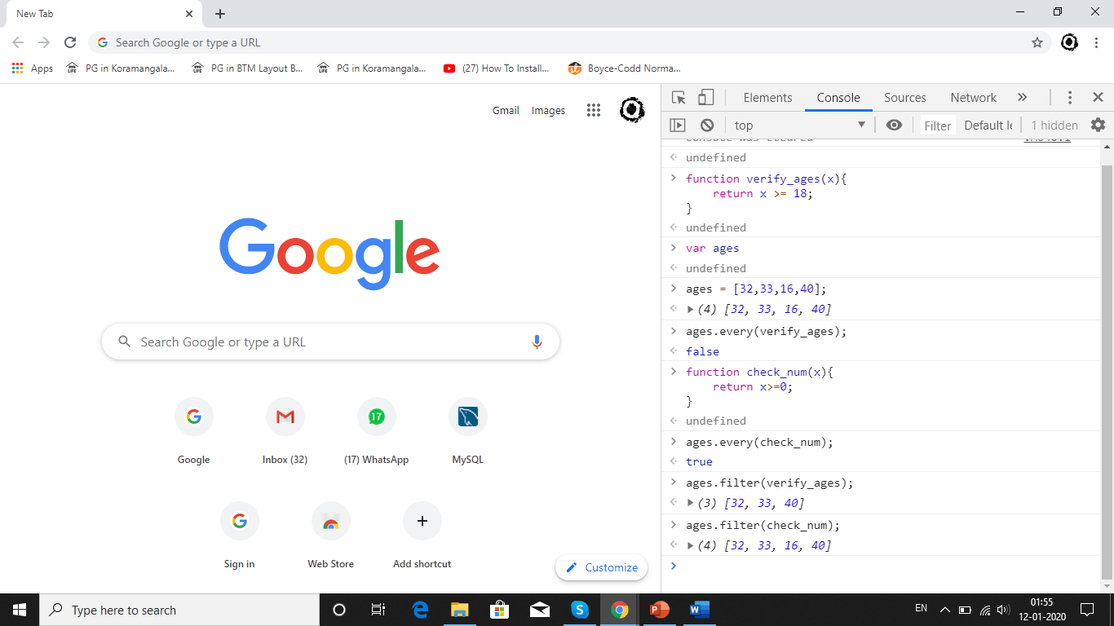

1. forEach()

var run = 0;

var over_score = [6,8,9,10];

function total_score(item){ run += item; console.log(run); }

over_score.forEach(total_score);

VM2356:3 6

VM2356:3 14

VM2356:3 23

VM2356:3 33

1. sort()

var num = [ 32,21,18,67,54,48,72,28,42 ]

num.sort()

*(9) [18, 21, 28, 32, 42, 48, 54, 67, 72]*

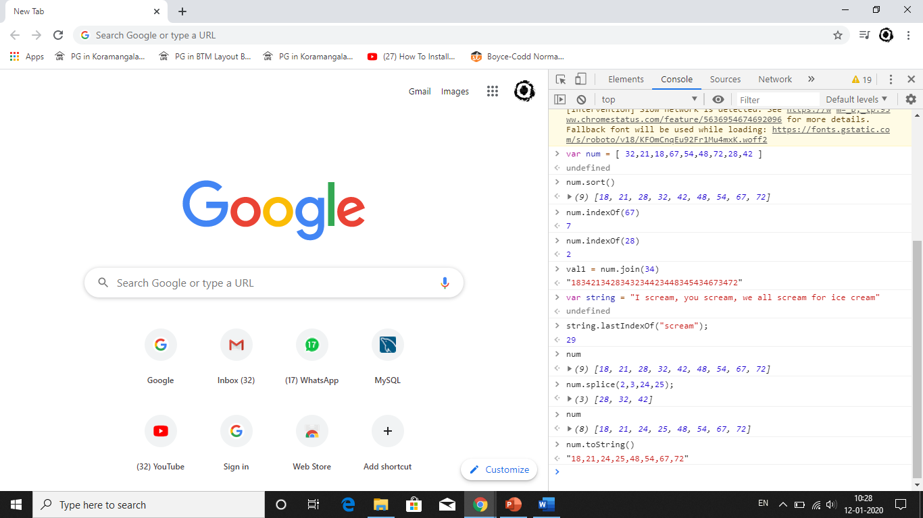

1. indexOf()

num.indexOf(67)

7

num.indexOf(28)

2



1. Join()

val1 = num.join(34)

"1834213428343234423448345434673472"



1. lastIndexOf()

var string = "I scream, you scream, we all scream for ice cream"

string.lastIndexOf("scream");

29

1. splice()

num

*(9) [18, 21, 28, 32, 42, 48, 54, 67, 72]*

num.splice(2,3,24,25);

*(3) [28, 32, 42]*

num

*(8) [18, 21, 24, 25, 48, 54, 67, 72]*

1. tostring()

num.toString()

"18,21,24,25,48,54,67,72"



1. map()

var numbers = [4, 9, 16, 25];

var x = numbers.map(Math.sqrt);

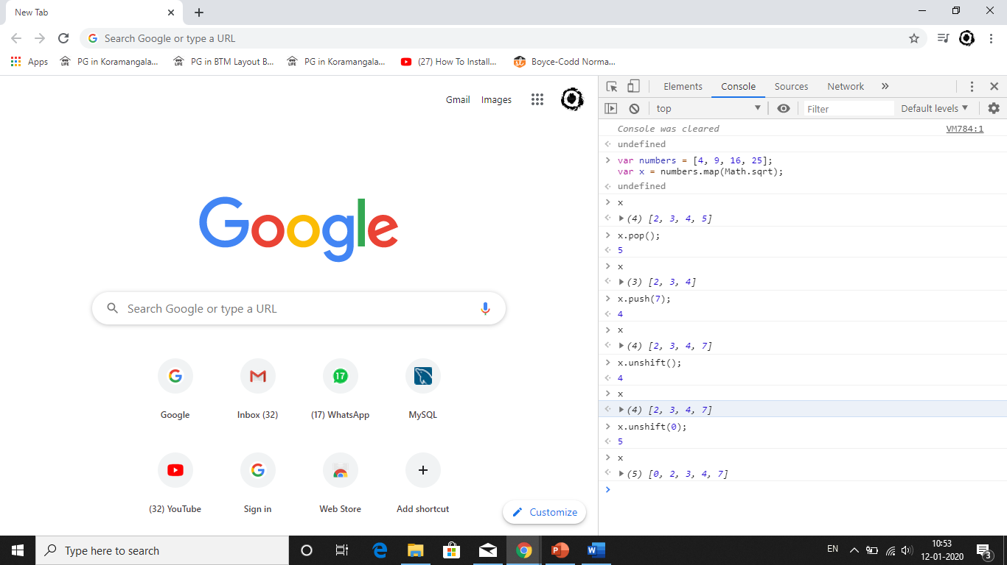

1. pop()

x.pop();

5



1. push()

x.push(7);

4



1. unshift()

x.unshift(0);

5



1. reduces()

var numbers = [175, 50, 25];

function myFunc(total, num) { return total - num; }

numbers.reduce(myFunc);

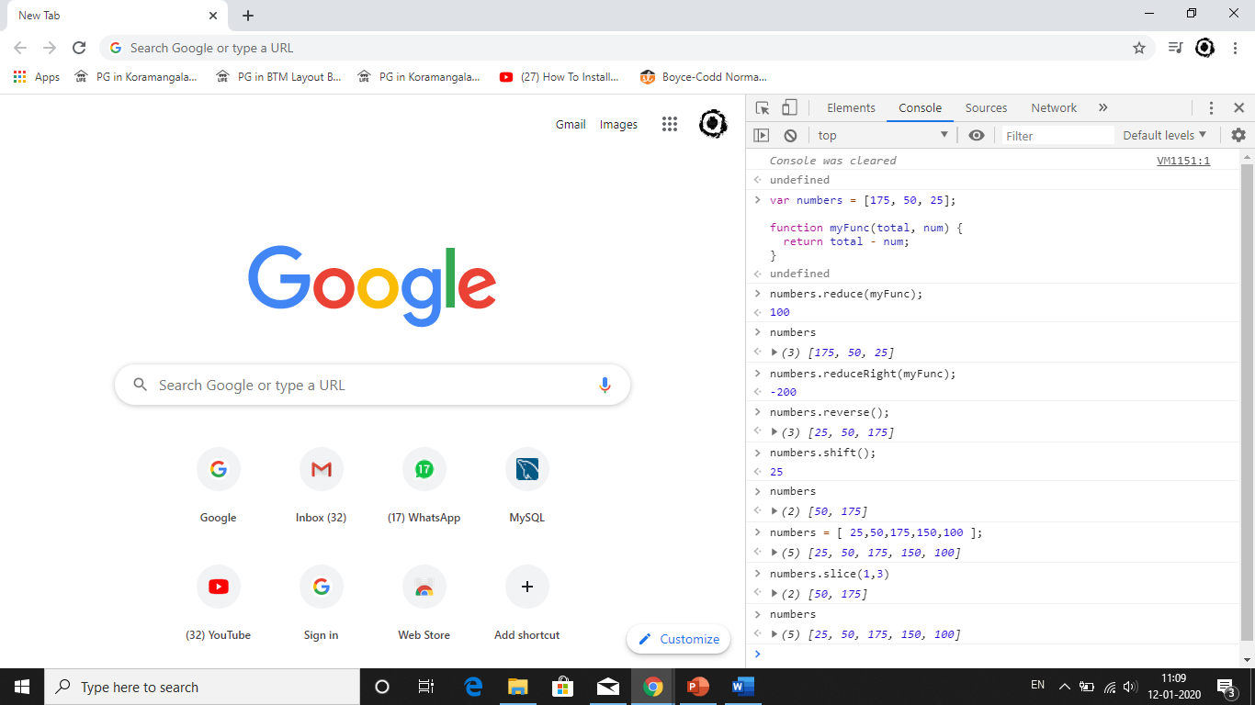

1. reduceRight()

numbers.reduceRight(myFunc);



1. reverse()

numbers.reverse();

*[25, 50, 175]*



1. shift()

numbers.shift();

25



1. slice()

numbers = [ 25,50,175,150,100 ];

numbers.slice(1,3)



1. some()

